**Know Your Customer - Case Study**

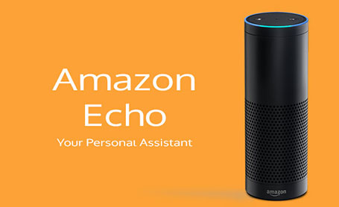

American online retail giant Amazon unveiled Amazon Echo, a voice-enabled digital assistant, to the Indian market on 6th November, 2014. The device, which comes to life with the key word ‘Alexa’, is a wireless speaker that can primarily answer questions, offer quick updates and of course play music.

**Product Features:**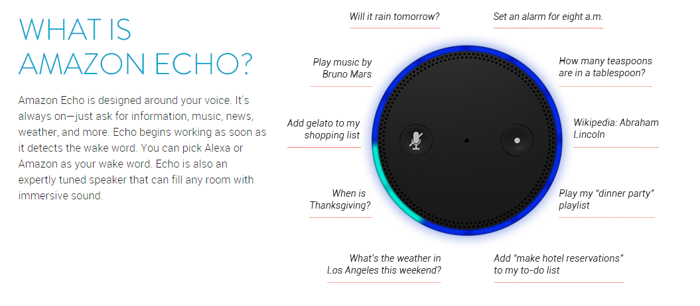

Further, its feature list is as follows:

* News, weather, and information: Hear up-to-the-minute weather and news from a variety of sources, including local radio stations, NPR, and ESPN from TuneIn.
* Music: Listen to your Amazon Music Library, Prime Music, TuneIn, and iHeartRadio.
* Alarms, timers, and lists: Stay on time and organized with voice-controlled alarms, timers, shopping and to-do lists.
* Questions and answers: Get information from Wikipedia, definitions, answers to common questions, and more.

Echo currently costs $199, or $99 for prime members in the Indian market. Additionally, the device is sold on an invitation-only basis. We’re intrigued, what do you think? Is having a Siri-like assistant your whole family can use convenient, or is it just overkill since so many smartphones have these features already?

1. How should Amazon segment the market? Who should be their target customers and how should they position their product?
2. Suggest both online and offline promotion and distribution strategy for Echo.
3. According to you, what additional features can be added to increase the utility of Echo?